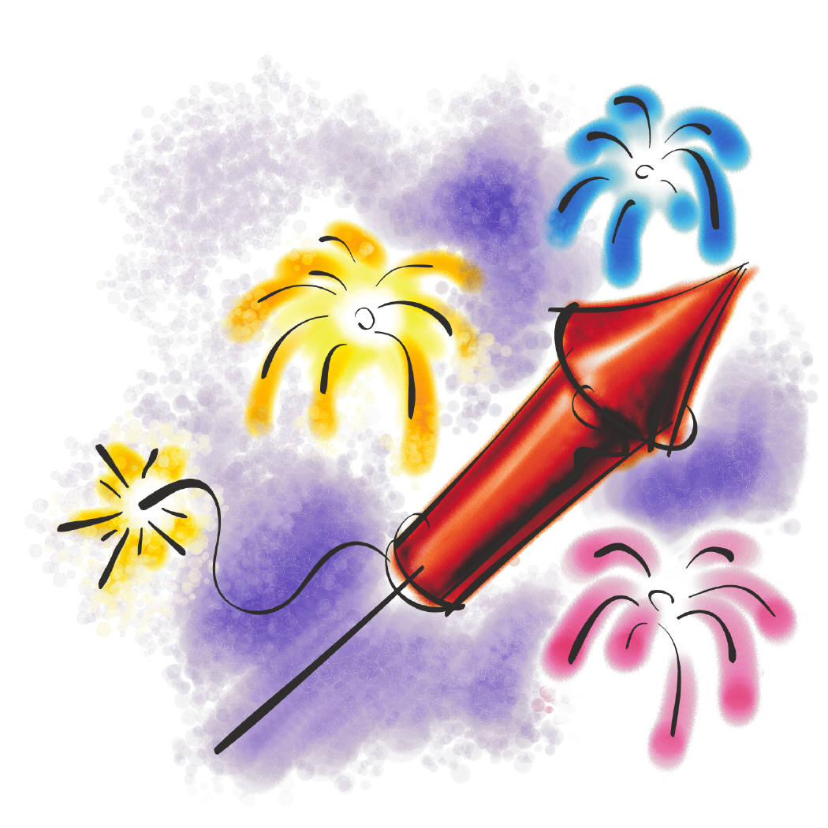

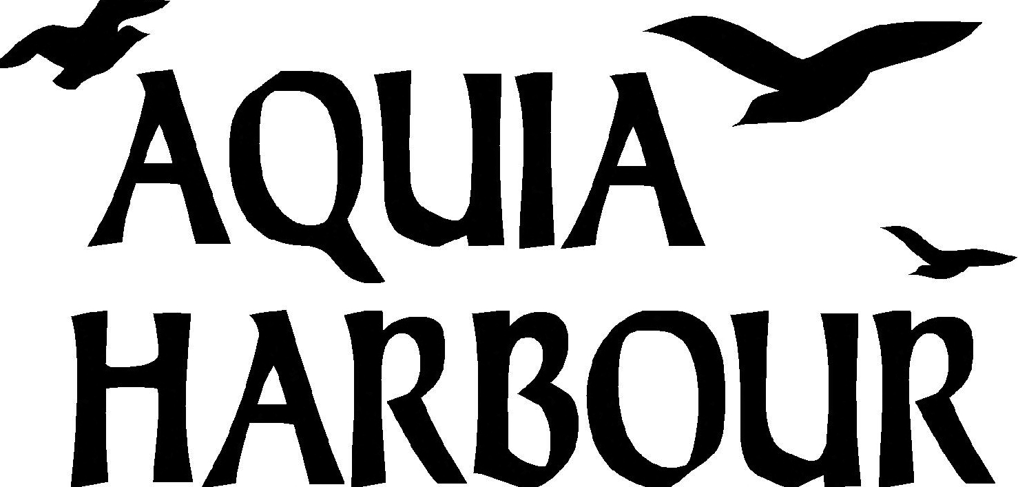

July 4th Vendor Space

Do you wish to show your wares or sell them?

We are looking for individuals and businesses who would like to sell products at the July 4th Celebration, located at Lion’s Park from 10:00a to 2:00p, July 4, 2017. You can setup before 9:00a or after 10:15a. Limited space is available so act now. Should the event be cancelled due to weather, the rain date for our event is July 8, from 10:00a to 2:00p.

☐ 10’ x 10’ cost is $25.00 for Non-Residents (NON-REFUNDABLE). There is no cost to Residents. You will need to supply your own table, chairs, tent, etc.

Name: ____________________________________ Group: __________________________

Address: ____________________________________________________________________

E-mail: _______________________________________ Telephone:____________________

In consideration of the acceptance of the right to participate, entrants, participants, spectators, family, and guests, will at all times indemnify and hold harmless the Aquia Harbour Property Owners Association and all of its employees, agents and officers, from all responsibility known and unknown for damage, injury, judgments, claims or liability arising from participation in the AHPOA July 4th, 2017, Independence Day Parade and all Event activities. I HAVE READ AND UNDERSTAND THE ABOVE STATEMENT.

Signature: ___________________________________________________ Date:_______________________
Send Registration form and check* to: Julia Regan, 200 Beacon Cove, Stafford, VA 22554.
****Make check out to Aquia Harbour Property Owners Association****
Please direct any questions to Julia Regan at jeweleah822@msn.com
Aquia Harbour Residents and Invited Guests Only
REGISTRATION MUST BE RECEIVED BY FRIDAY, JUNE 26.

