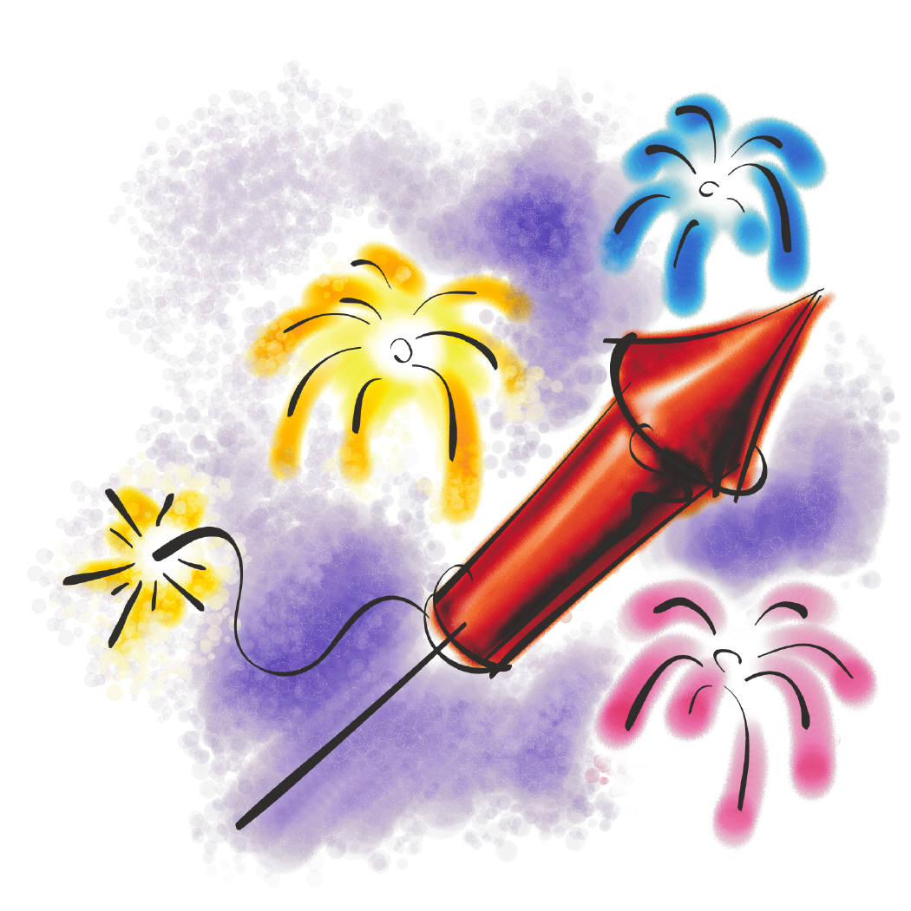
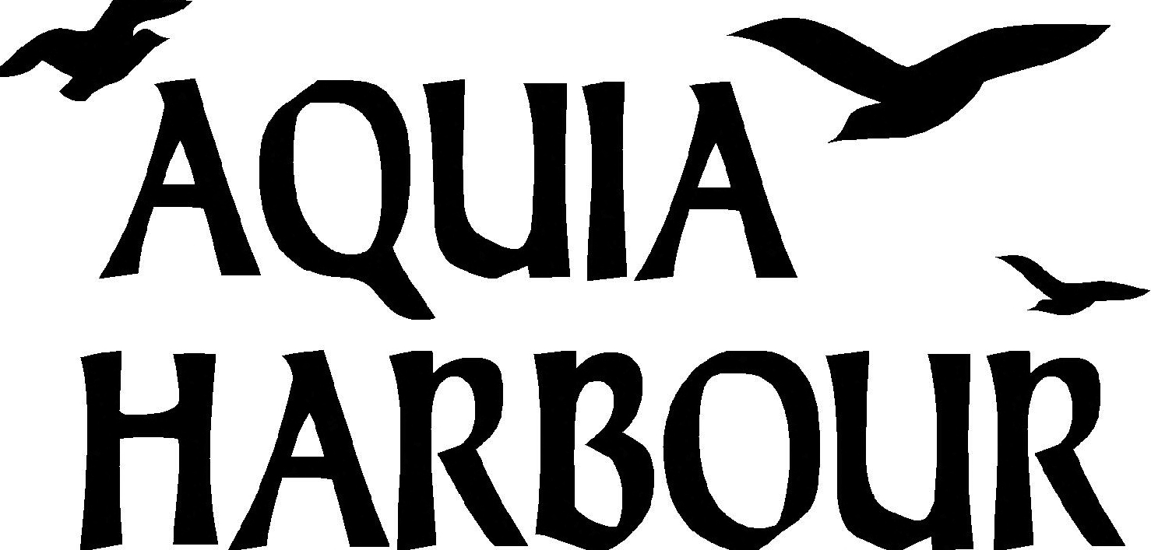

July 4th Independence Day Parade
Start time: 9am **Rain date: Saturday, July 8th

PARADE REGISTRATION FORM
Do you wish to participate in our Parade? We are looking for individuals, clubs, groups, organizations and businesses who would like to:
☐ March in Parade ☐ Provide a Parade Float ☐ Dress in Costume or Uniform ☐ Play Musical Instruments
☐ Drive a Classic or Eye-Catching Vehicle ☐ Other _______________________________________
**Children on bikes/walking need not register. Please arrive by 8:30 at the walking path on Vessel Drive.
Name: ____________________________________ Group: __________________________
Description of vehicle/float/costume:__________________________________________
Address: ____________________________________________________________________
E-mail: _______________________________________ Telephone:____________________
In consideration of the acceptance of the right to participate, entrants, participants, spectators, family, and guests, will at all times indemnify and hold harmless the Aquia Harbour Property Owners Association, the Community Events Committee and all of its employees, agents and officers, from all responsibility known and unknown for damage, injury, judgments, claims or liability arising from participation in the AHPOA July 4th, 2017, Independence Day Parade and all Event activities. I HAVE READ AND UNDERSTAND THE ABOVE STATEMENT.

Signature: ___________________________________________________ Date:_______________________

If you have questions or need information please call:
Julia Regan at 703-303-3195 or Anna Killion at 703-980-5513
Email registration to ahcec.parade@yahoo.com

REGISTRATION MUST BE RECEIVED BY Saturday, June 17th.

